Practical - 2

Practical Title: Semantic HTML5 Pages with Accessibility-
Ready Structure

Problem Definition: Develop static HTML5 skeletons for at least 10 StudentHub pages such as Home, About, Register, Login, Dashboard, Events, Profile, Contact, Admin, FAQ, and Feedback. Use semantic tags and accessibility-friendly structure.

- Implementation/ Output/Result

https://github.com/margiruparel2907-collab/webdev/tree/master/HTML

- Evidence of Work (Screenshots)
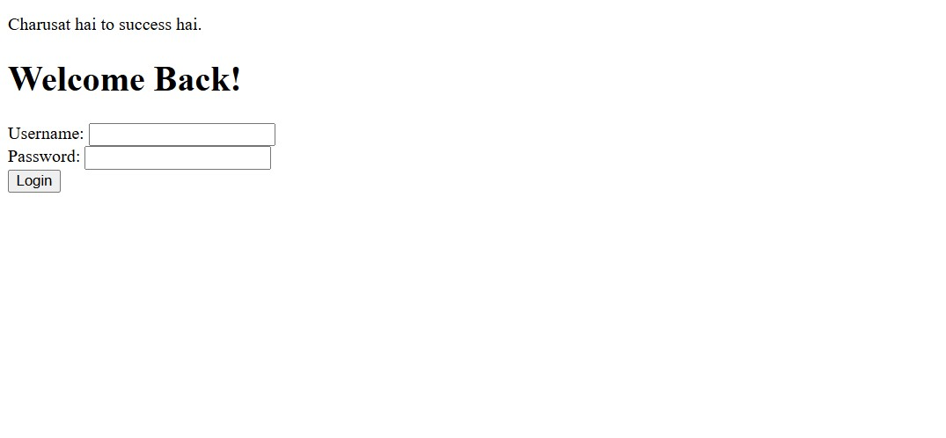
Description: Login Page.

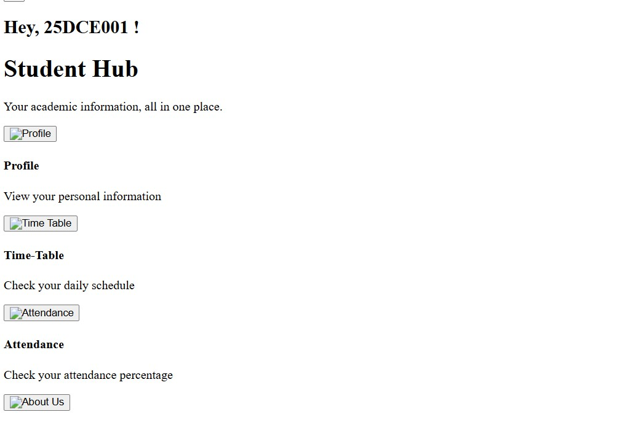
Description: Dashboard

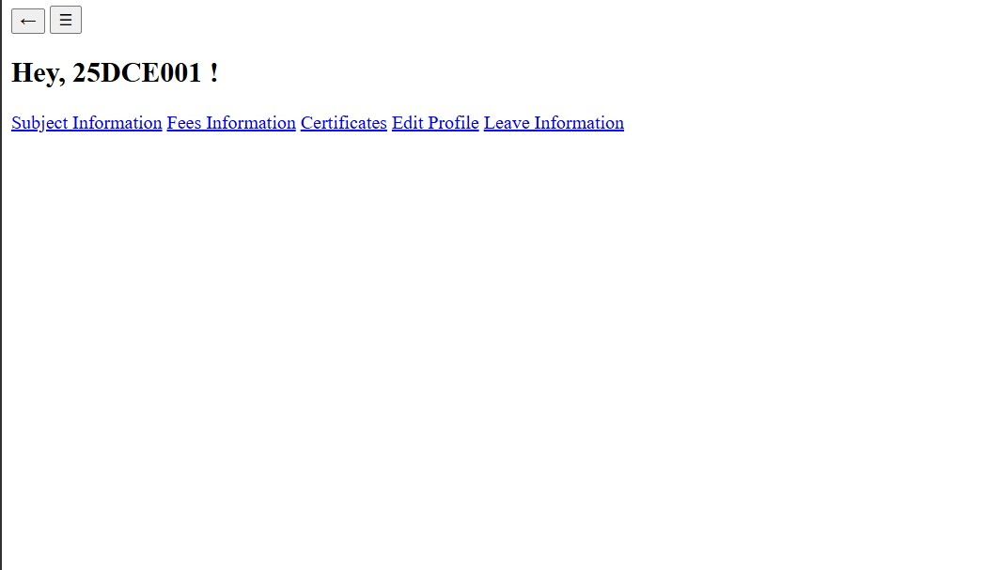
Description: Menupage
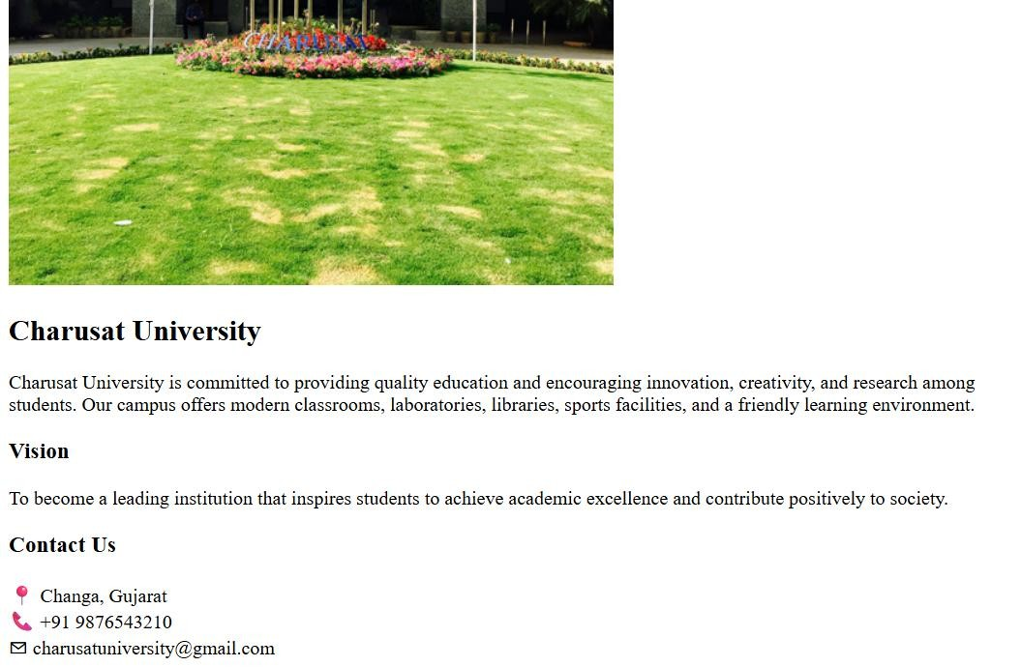

Description: AboutUs page
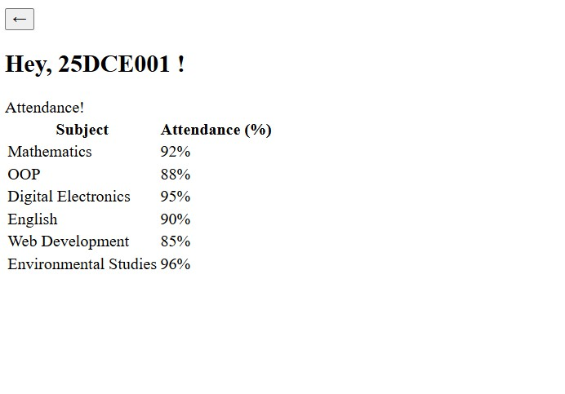
Description: Attendance page
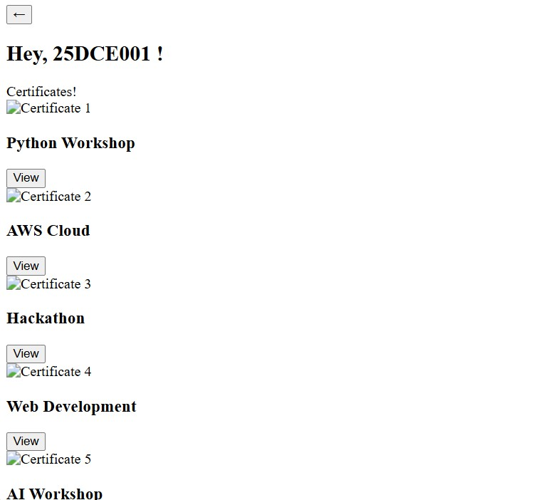

Description: Certificates
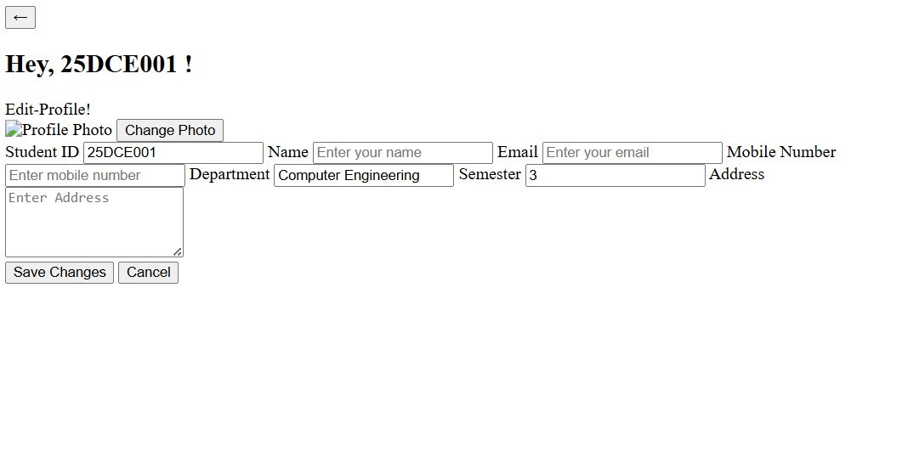
Description: Edit profile page
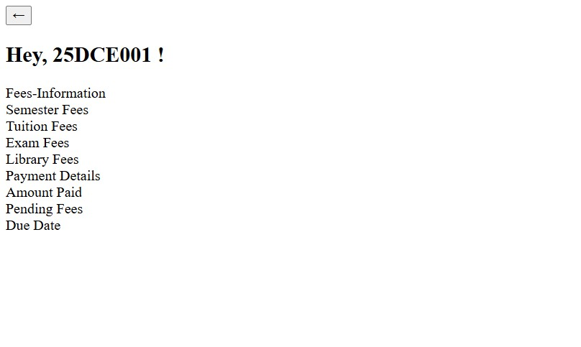
Description: Fees Information
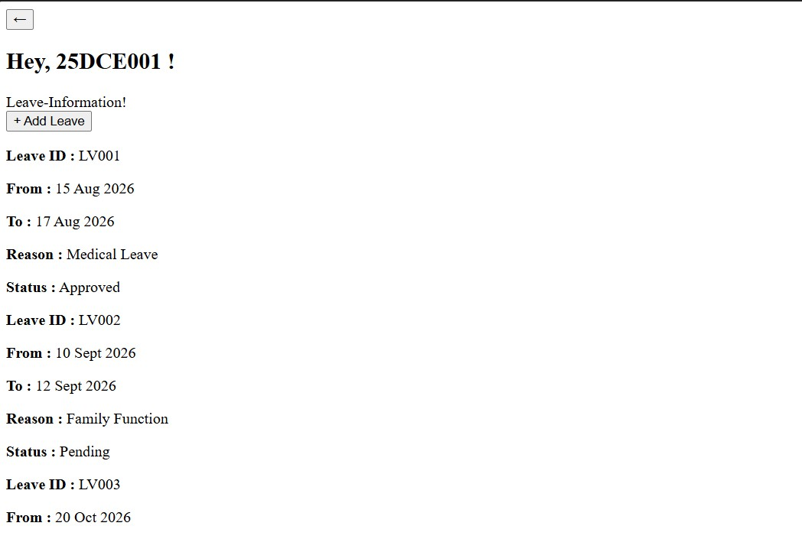

Description: Leave Information

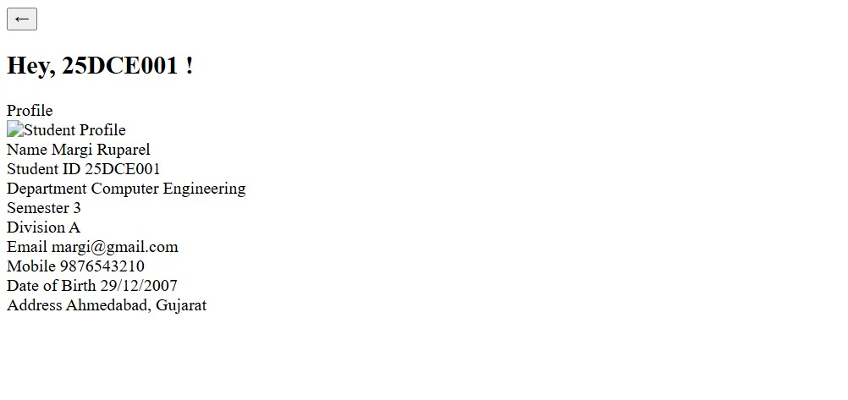

Description: Profile page
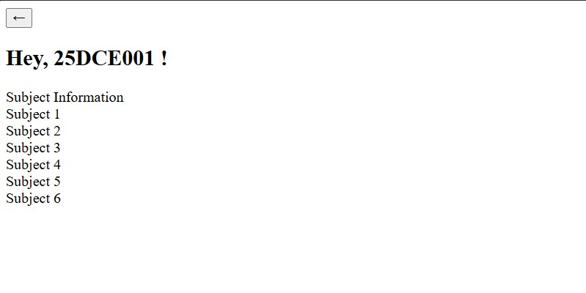
Description: Subject info page
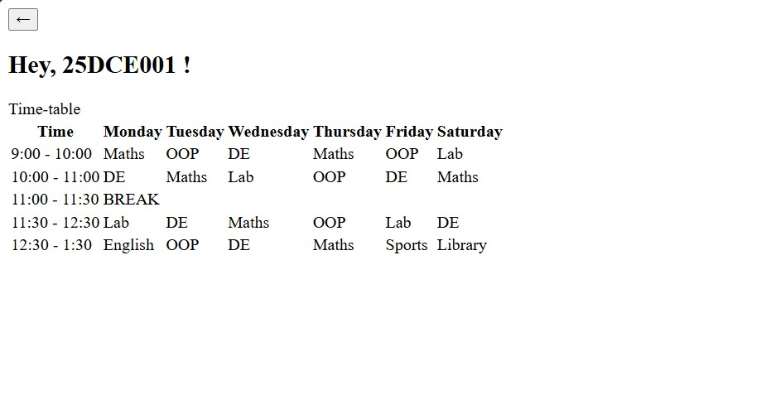

Description: Time-Table Page

- GitHub Repository Link:
https://github.com/margiruparel2907-collab/webdev

- Challenges Faced:
While developing the StudentHub portal, I faced several challenges. Initially, arranging different pages such as Login, Dashboard, Profile, Attendance, Timetable, Certificates, Fees Information, and Leave Information was difficult because I had to make sure all pages were connected properly through navigation links. I also faced issues while creating tables for attendance and timetable, as the data was not aligned correctly. Another challenge was adding images and icons because some images were not displaying due to incorrect file paths. Designing forms for profile editing and leave management was also challenging as the input fields were not properly arranged. Maintaining a consistent layout and appearance across all pages required multiple changes in the CSS code.
By solving these issues, I gained a better understanding of HTML page structure, CSS styling, image handling, and webpage navigation. The final output successfully displays all the required modules of the StudentHub portal, including Login,
Dashboard, Profile, Attendance, Timetable, Certificates, Fees Information, Subject Information, and Leave Information. The project helped me improve my web development skills and understand how different webpages can be connected to create a complete student management portal.

- Learning Outcomes:
Through this practical, I learned how to design and develop a multi-page website using HTML and CSS. I learned to create tables, forms, navigation menus, and information cards. I also understood the importance of proper page linking, layout management, and user-friendly design. This practical improved my problem-solving skills and provided hands-on experience in creating a basic student portal system.

Faculty Remarks: (Keep this blank for faculty)

